Stairwell lightboxes
Lightbox A
Artist - Shi Dong
Title - Imperfection Series
Media - Acrylic, Charcoal, Watercolour on Paper
BIO - Shi Dong is originally from Beijing, China. Shi went to San Francisco to pursue a master’s in fine arts and Art Education in 2011. Now, Shi is a Ph.D. candidate at RMIT. Her paintings are inspired by Zen concepts and nature.
SOI - Particularly in possible relation to living in a post-lockdown communications environment this work from my Imperfection series was inspired by Zen concepts, Wabi-sabi aesthetics, and calligraphy dry brush technique. During the 5km lockdown period, I painted this in my garage. The painting process is a way of daily meditation for me. The control of brush and finding the balance in the composition helps me to reach a feeling of inner peace in life.

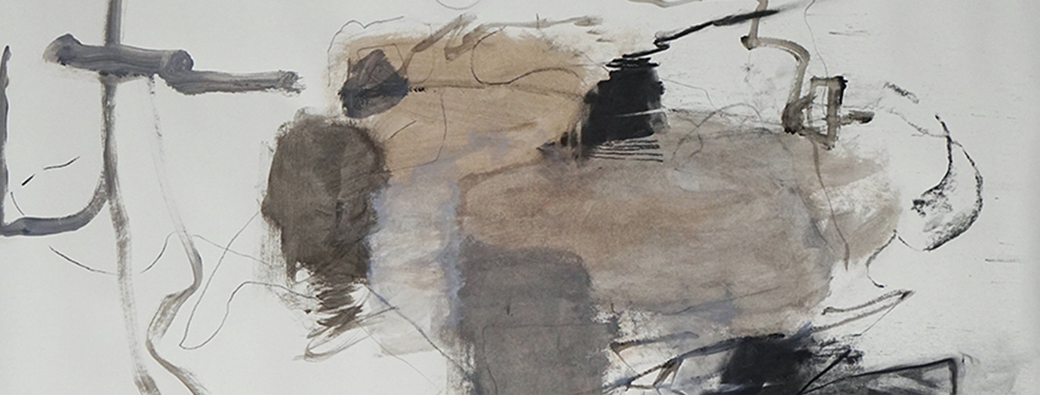

Lightbox B
Artist - Holly Brown
Title - Don’t lose your head
Medium - digital collage
BIO My contemporary artistic practice embraces experimental and diverse scenography, and digital collage compositions. I engage in the art of consideration and collection of imagery to generate these layered compositions. Text can be a contradicting element within the works, yet they are not straightforward expressions of my views.
SOI -The artwork is a loose response to the restrictions our society has faced during the lockdown. The text is a boldly phrased suggestion, acknowledging the mental state many struggled to maintain. However, it can also be viewed in a humorous nature according to one’s perception.
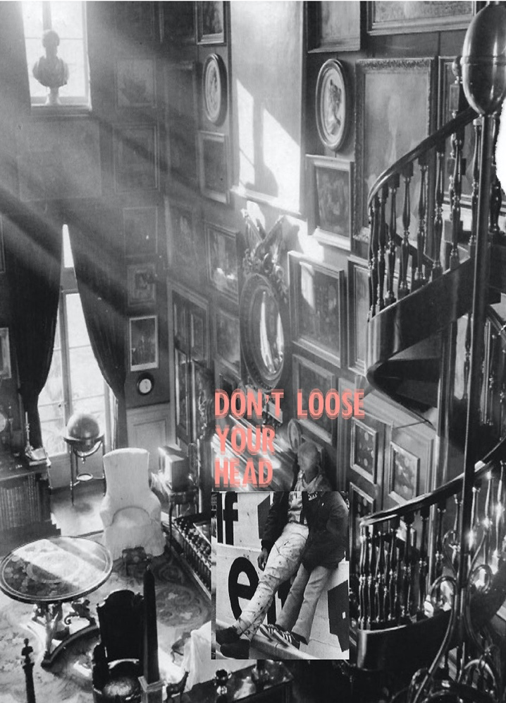
Lightbox C

Artist: - Aaron Ashwood
Title: A'Beckett St
Media: photographic print
BIO Aaron Ashwood is a Tasmanian artist currently Based in Naarm/Melbourne, where he has undertaken his Bachelor of Fine Arts degree at RMIT University. Aaron’s practice is multidisciplinary, playing out in the interactions and slippages between painting, sculpture, print, sound, video, photography and installation. SOI- This photographic work titled A'Beckett St, contains a painting which I have moved out on the street from my University studio. By doing so I aim to question relationships between art-object and its environment. How does the work change the location? How does the location change the work?
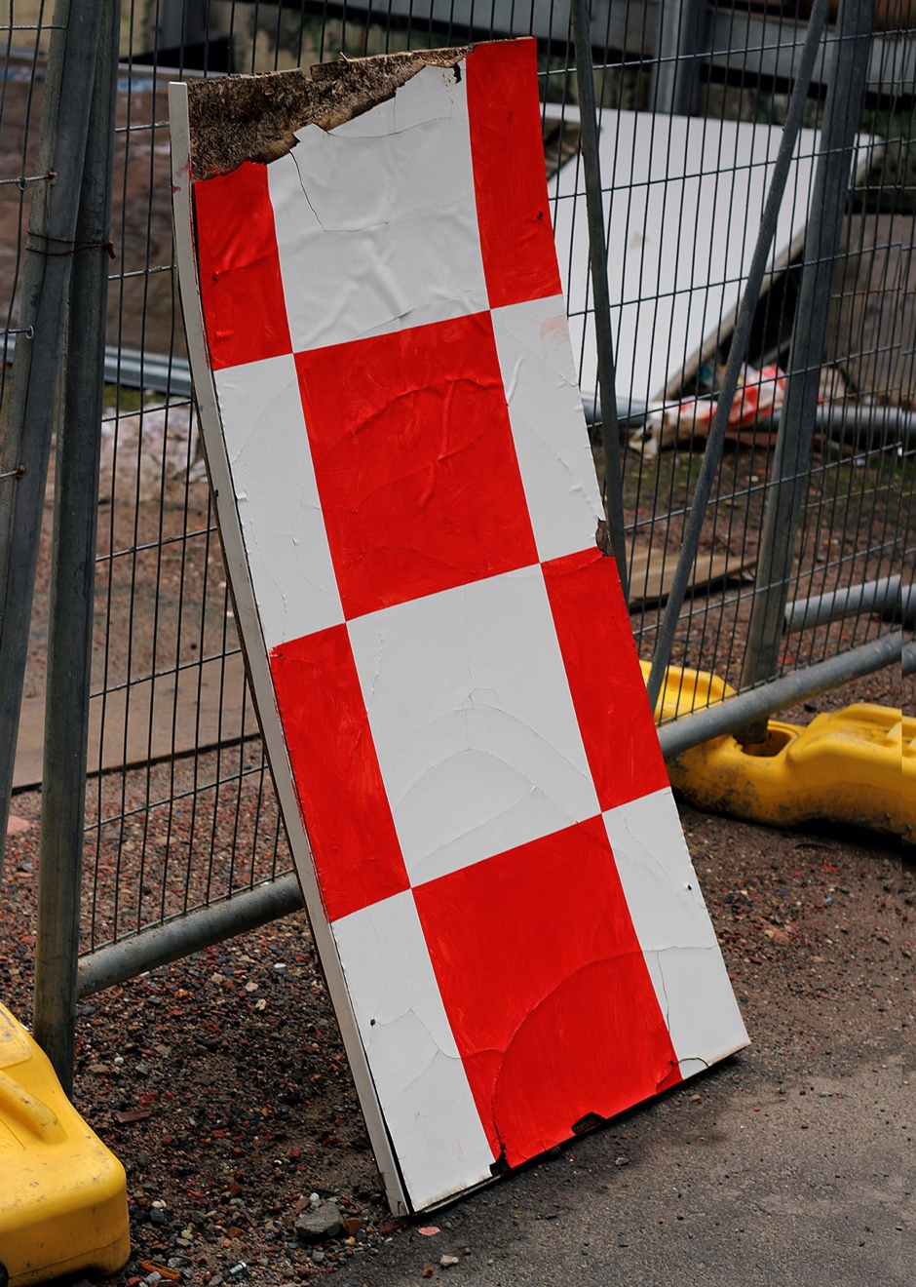
Rodda Lane

Lightbox D
Artist: - Cameron Hennessy
Title - SPACEWOMEN
Media - Screen Print

SOI- The poster is a play on words using the phrase ‘take up space’. It promotes the inclusion of women in traditionally male dominated spaces, one of which is outer space itself. This artwork is about the importance of creating safe spaces for people that exist anywhere along the gender spectrum.
This work was made after considering my personal fascination with the moon and realising that no woman had ever been there.

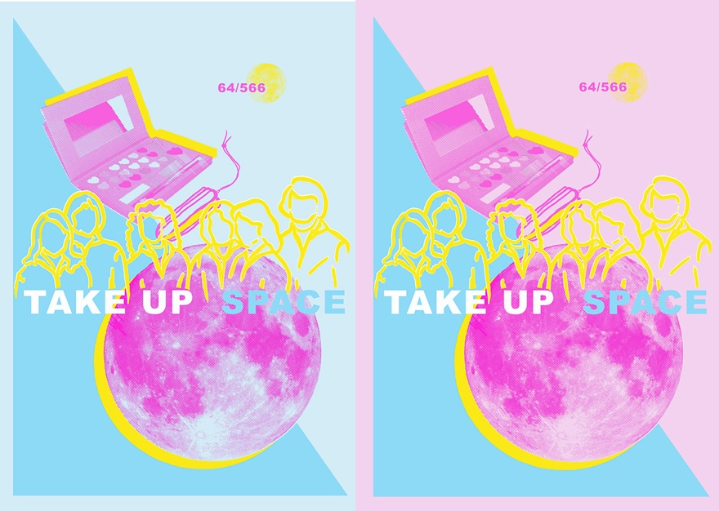

Lightbox E
Artist - Sophie Calalesina
Title - A guide to women's personal safety; inclusive of the devil's advocate' Medium: Screen print and digital collage
BIO - Sophie Calalesina is a third-year fine arts student, majoring in printmaking. She works mainly with linocut prints and is experimenting with screen printing and collage, particularly with the use of found paper sources
SOI - This was created as a response to the barrage of safety tips aimed at women, especially in response to violent crime. Furthermore, a majority of the perpetrators of sexual assault against women are someone she knows, rather than a stranger. Therefore these “preventative tips” just amount to victim blaming.
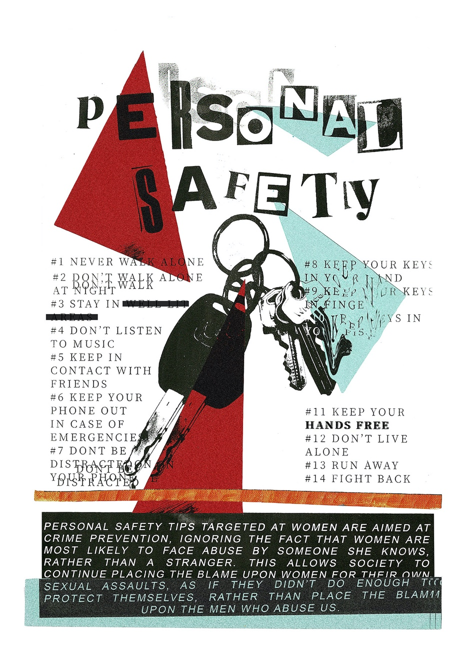

Lightbox F
Artist: - Brooke Murray
Title - Reclaiming the body (2021) Media -Photograph on digital print
“I am a multi-disciplinary art student majoring in Printmaking with interests in photography and installation works. My work is process driven with materiality playing an important role in the making. I like to use ephemeral materials as well as found objects to show a transition.
SOI -Since lockdown I’ve been exploring my identity using photography and documentation of the body, altering between self-portrait and selfies as a way of reclaiming the body. This artwork was created to challenge traditional female beauty standards and to momentarily normalize modified bodies”.
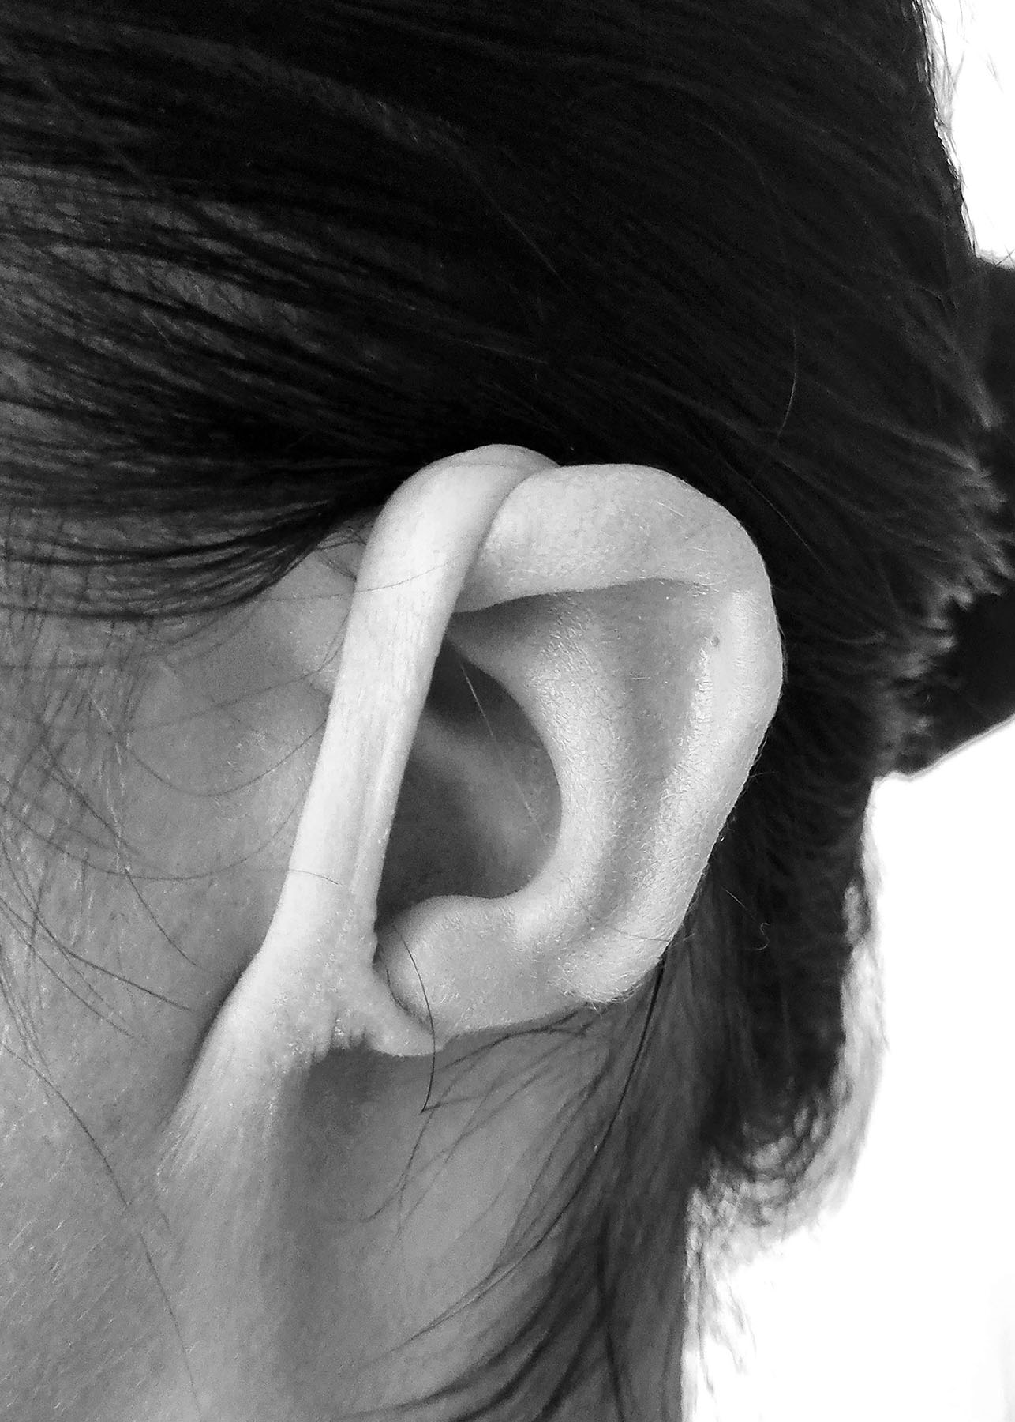

Lightbox G
Artist - Sophie Quinn
Title - Peel
Medium - patinated brass, 30 x 15 cm
BIO - Sophie Quinn is an emerging contemporary artist who works across disciplines. After completing her undergrad at ANU, Sophie went on to complete honours art RMIT in 2020. Sophie works in two and three dimensions, often exploring the tensions that exist between traditional and non-traditional materials.
SOI - This piece considers the way relationships and human connection have been impacted by the Covid-19 pandemic and social distancing. By interrogating certain concepts – such as masking and protecting – my aim is to explore the challenges of connection and concealment and the way, as individuals, we must expose ourselves to create meaningful relationships.
.
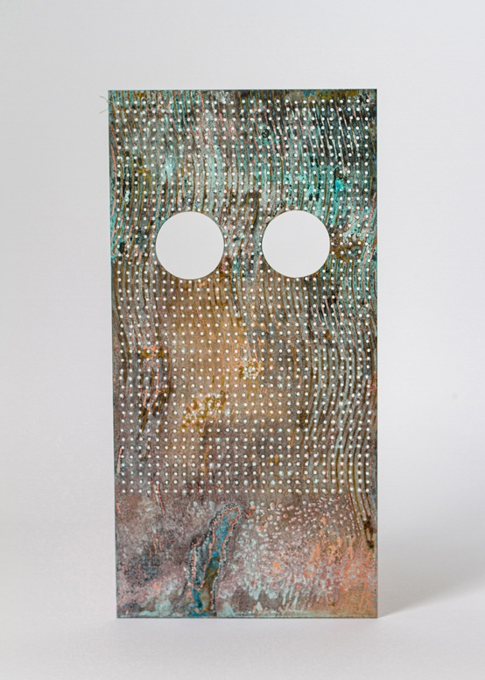

Lightbox H
Artist - Holly Brown
Title - Take Control
Medium - Digital print (dim.variable)
BIO -My contemporary artistic practice embraces experimental and diverse scenography, and digital collage compositions. I engage in the art of consideration and collection of imagery to generate these layered compositions. Text can be a contradicting element within the works, yet they are not straightforward expressions of my views.
SOI -Lockdown was a period that resulted in many of us losing control. This artwork is an appeal to contradict against that, through the forceful tone of the text, punching through the heaviness of the year previous.

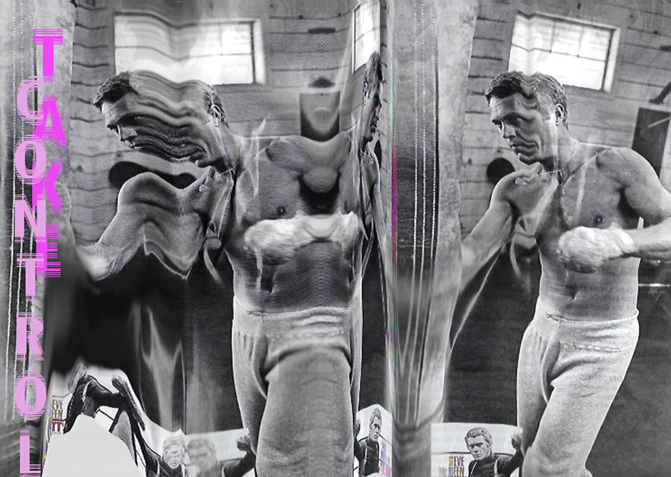

Lightbox I
Artist: Hira Tanao
TITLE: I am some ONE. I am no ONE. #1 (2020)
MATERIALS: paper, acrylic paint, pva glue, sand, ground glass, ground coffee, magnets
DIMENSIONS: dimensions variable
Bio: I, Nao Hirata, conduct art practice under the name of Hira Tanao which is derived from the name in Japanese order Hirata Nao veiling and unveiling translucent self. I am currently studying a Bachelor of Fine Art (Gold and Silversmithing) at RMIT.
SOI: I approach self as a mutable and elusive facet of surroundings as a whole. Experiencing isolation under the lockdown in 2020 elevated my ongoing interests towards the ‘self’. I am intrigued by what forms who we are and how unexpected potencies like COVID reflect upon our being and life.
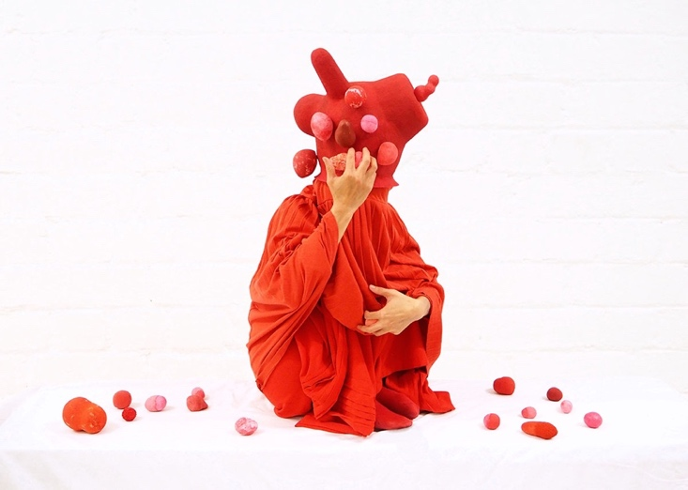

Knox Place
Knox Place Lightscapes - May 2021
From Left to Right: Hootan Heydari, Charlene Caday, Jasper Potter, Benjamin Sheppard and Jodie Flugge
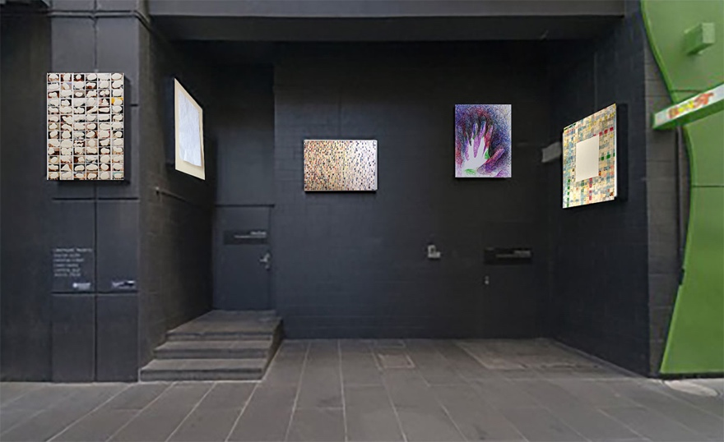

In the cave like recess along Knox place, five illuminated images arouse feelings and thoughts of what might be left absent. Marks are made, images and texts obscured or re-configured as the data of life is tantalisingly concealed, inferred or erased and ultimately made beautiful. As we slowly emerge from a seclusion complicated by the increase of online communication (thanks to the ‘pandemic that shall not be named’) we come to realise the online experience is mediated through processes of curation–editing and re-formulations that deprive us of authenticity. The works in Knox Place Lightscapes, while produced from a variety of intentions and methods, are pregnant with content alluded to, avoided or erased through differing strategies of visual privation and inference. It is an obscure arrangement, analogous to the changeable realities and obfuscations of the current moment.

Lightbox J
Hootan Heydari Untitled 2019, Photographic images and plaster. Courtesy of the Artist
Hootan is a multidisciplinary artist, exploring themes of migration, identity and memory. With an Honours degree from RMIT University he is currently undertaking a Master of Fine Art at the Victorian College of Arts in Melbourne.
A matrix of photographs reproduced from the artist’s family archive is systematically concealed. The use of ‘non-originals’ questions the deification of the photograph as an object. Each of these images is interrupted by an amorphous piece of plaster over the faces of their subjects. Plaster is a material used to heal broken bones, build homes or take imprints of whatever it comes into contact with. Partially concealing information by blocking out the faces of the subjects repetitively (and compulsively) could be interpreted as a sign of ‘madness’, or equally as an attempt to preserve and heal the past in the current moment. Regardless, this repetitive analogue gesture revisits historical moments to diffuse the weight of a personal history

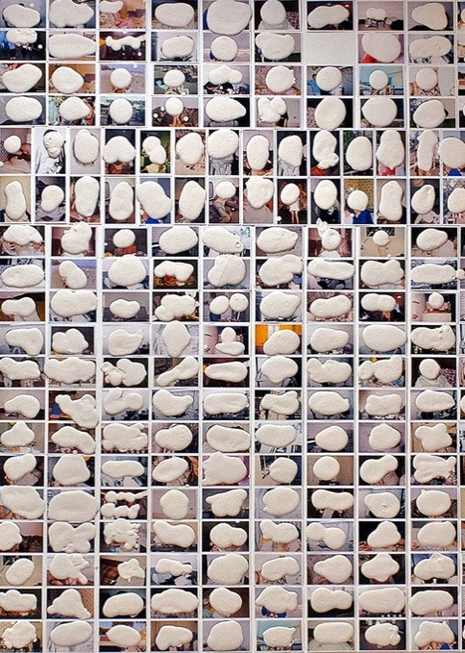

Lightbox K
Charlene Caday The Edge, 2021 Creased and perforated paper Courtesy of the Artist
Charlene is a Melbourne based artist currently studying a Bachelor of Fine Art at RMIT. With a background in fashion, her mixed media practice spans sculpture, textiles and drawing; where she documents conversations between material states as a technique to generate drawn records of movement and exchange.
In The Edge, the folded edges of a re-flattened piece of paper are traced with fine perforations. As gesture, it examines the results of a common material after the obliterative transitional action of being screwed up. A meticulous revisitation of a past event, this ritualistic observation echoes the scrupulous revisitation of a past acts in general–a contemplation of how personal encounters of living through the pandemic influence and evolve our way of making ‘sense’ of it all.

Lightbox L
Jasper Potter Disintegration, 2021 Ink on gridded sketch paper Courtesy of the Artist
Jasper is a visual artist and student of Fine Arts in Drawing at RMIT. He works professionally as a Graphic Recorder; capturing conversations and presentations visually through live illustration, text and mind-mapping.
A data set reflecting mundane, day-to-day experience is transcribed using several algorithms to generate the colourful, linear visual mapping displayed. As part of a large body of work, the constituent elements of line, colour and the gridded form map and reiterate a variety of abstractions completely decoupled from the initial data. In a time of data saturation, these works make beautiful the factual rhythms and patterns of a life that is not always felt as such.
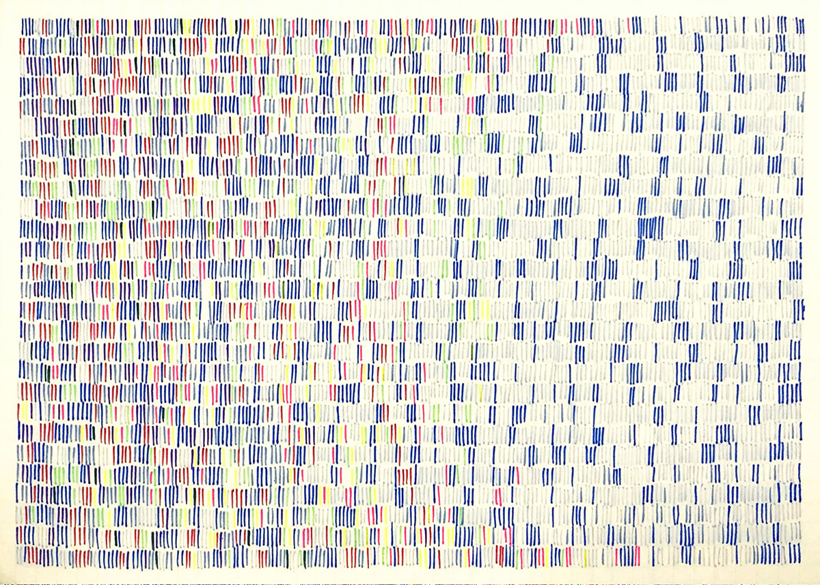

Lightbox M
Benjamin Sheppard, 2021, Scribble Me This...(hands) pen on paper Courtesy the Artist
Benjamin is a multi-disciplinary Melbourne based artist and academic working at RMIT. The work here is taken from a continuum of works on paper exploring the potential for ‘drawings in-progress’ to reflect who we are and how we communicate that in the contemporary moment.
In the cave like alcove of Knox place, one of five light boxes illuminates scribbled fields of colour leaving absent the familiar form of a hand. Layer after layer, reflecting moment after moment, absent hands call out as if to say ‘I was here!... or perhaps, I’m still here...!’. Recalling the same gesture in cave paintings common across continents and cultures, the presence of these repeatedly overlayed, almost waving, hands remind us of the human compulsion to mark presence. From the caves of pre-history to the selfie- dominated online salute, we are still saying, I am here. We are all still here.
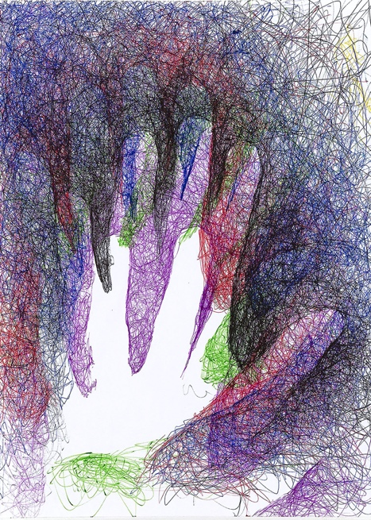

Lightbox N

Jodie Flugge Not Titled, 2020 Artists own letters, beeswax, pigment and card on MDF Courtesy of the Artist
Jodie is a mixed media artist exploring material deconstructions and reconfiguration. She is completing a Batchelor of fine Arts in painting at RMIT.
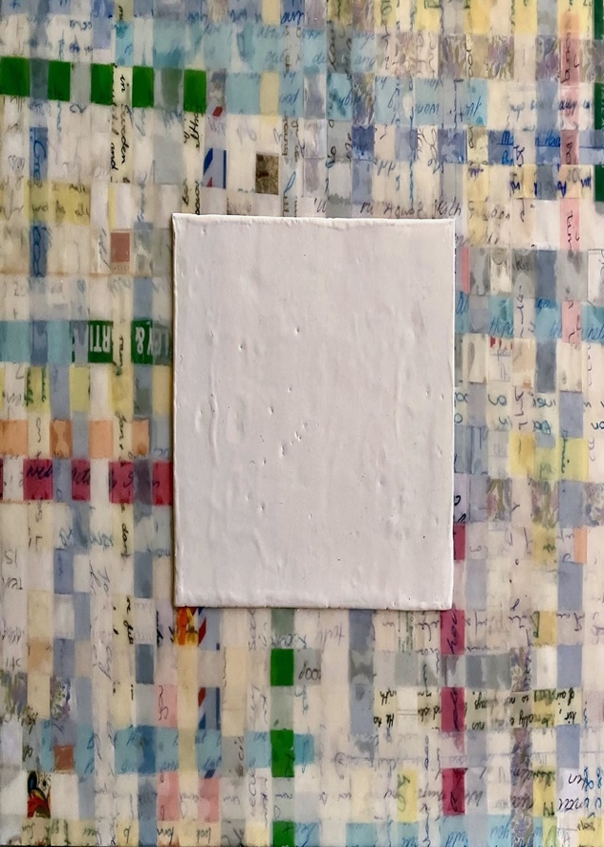
Before Covid was upon us, I was going through all the mementoes, letters, diaries I have kept since I was 15. Reading letters from family, friends and past relationships filled me with nostalgia, melancholy, embarrassment and a strange sort of disconnectedness from my younger self. I resolved never to read them again. I also decided that I didn’t want my kids to read them ,or have to deal with them after I die. Throwing them out wasn’t an option. With statistics of death and infection constantly delivered throughout COVID, these numbers took on new meaning. So many numbers and with every number comes a family dealing with the aftermath. Dealing with my archive of memories took on a new urgency. The resulting process aimed to obfuscate– making unreadable, while somehow retaining, those memories.

